|  |  |  |
| --- | --- | --- |
| Dear Data | Dear Data | |
| Name: | Ana Margarida Almeida |
| Num: | 102618 |
| Date: | 2024/10/01 |

# Front

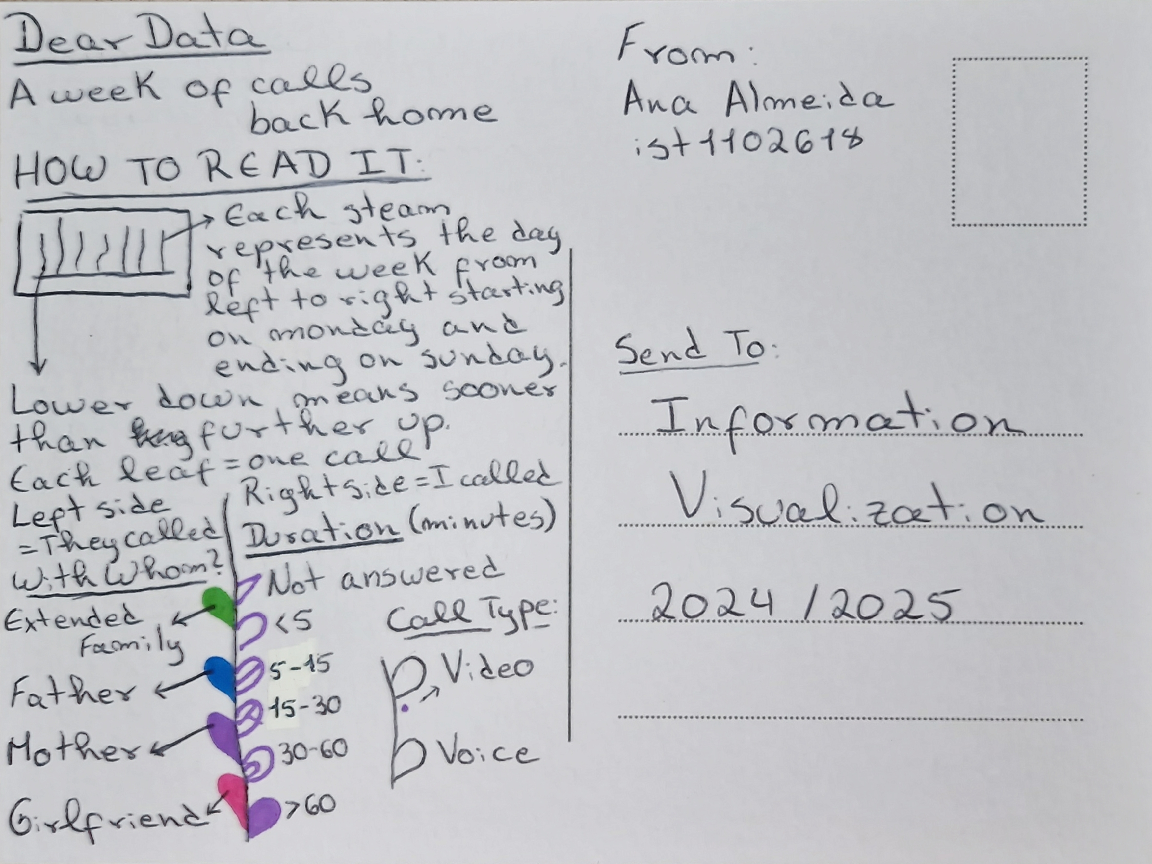

# Back

